Lab - CVE and CVSS
- Find a CVE and extract details (Individual)
Ethan Perdieu
https://nvd.nist.gov/vuln/detail/CVE-2026-1963
CVE ID: | CVE-2026-1963
Vulnerability Name: | WeKan Attachment Storage Improper Access Control
Description: | Vulnerability was found to affect WeKan up to version 8.20. It affects the function of the attachments.js component storage. WeKan is an Open-Source Kanban resource that allows for efficient task management. Can be launched remotely.
Affected Software/Systems: | WeKan versions up to and including 8.20
Common Vulnerability Scoring System (CVSS) (severity, not risk measurement): | 5.3 Medium CVSS Score  CVSS:4.0/AV:N/AC:L/AT:N/PR:L/UI:N/VC:L/VI:L/VA:L/SC:N/SI:N/SA:N
Stakeholder-Specific Vulnerability Categorization (SSVC) model: | I could not find it on website and there is no current listing for this CVE
Potential Impact: | Remote users that get authenticated can use improper access controls to view and manipulate attachments that should not be accessible.
Exploitation Details: | Attack vectors could exploit the faulty API to gain access. Server could not properly validate whether the user should have access to an image since it’s a faulty API.
Mitigation Strategies: | Upgrading WeKan to 8.21+ You can also view access logs to ensure that no suspicious activity ended up occurring
Real-World Example of CVE in the wild: | There were no apparent real-world examples because this was patched same day back in February 5th
Is there a fix or patch? If so, explain. | Yes, there was a security issue released with version 8.21. The fix implemented authentication checks and storage allowlisting to prevent this in the future.

https://www.cisa.gov/known-exploited-vulnerabilities-catalog

- Expand on CVE findings (Individual)
  - Based on your CVE, explain how you would exploit this CVE.
    - Attacker requirements:

Must have a user account with WeKan (any account since they didn’t have an authentication instance)

Need to have any type of network access so you can access the WeKan Server

Some prior knowledge regarding enumeration

    - Victim environment (OS, apps, dependencies… etc.)
MUST be on version 8.20 or earlier to prevent patch

Running on any OS

Attachment storage features must be available

No other special requirements

    - Isolation / safeguards if going to attempt
Run WeKan v8.20 or before in an isolated environment on a virtual network. This network should be secured and should be host-only

You should take a snapshot before the testing phase in case something goes tragically wrong

No internet connection from the test environment (ENSURE)

Use two separate test accounts where one has no board access and one has access

    - Expected outcome
The attackers’ low privilege account should be able to manipulate all attachment files belonging to boards they have no access to.

    - Vulnerability condition triggers (do not procvide any exploit code)
The vulnerability itself is triggered when the atachments.js function located in the model’s folder gets a move request. This occurs without authentication meaning the server processes the request based solely on the attachment ID rather than verifying the user ID.

    - Reproducibility plan
1. Register as a user using the WeKan Service

2. Identify or enumerate a attachment ID belonging to another board that you do not have access to

3. Send a QPI request to the attachment storage endpoint referencing that attachment ID previously stated

4. Server should except the request even though you do not have authorized access

5. Confirm the attachment was accessed/modified

- Apply critical analysis on your scan results from other labs
Detected Vulnerability | Host/Service | CVE (if any) | Severity (Tool) | Potential Impact | Next Steps if Exploiting
Example: OpenSSH Banner Disclosure | 10.0.2.15:22 | CVE-2020-15778 | Medium | Info leak | Determine version, research exploitability
Anonymous DH Key Exchange | 10.0.2.15:3306 | CVE-2015-4000 | High | MitM attacker can intercept full database communications that communicate in plaintext. | Attempting traffic interceptions on the network
.git/HEAD Directory Exposed | DVWA Host:80 | N/A (CWE-538) | High | Full source code and credentials are accessible | Confirm directory is publicly readable, enumerate exposed files
FTP Directory Publicly Accessible | Juice-Shop Host:80 | N/A | Medium | Anyone can download files from the /ftp path without authentication | Enumerate and download all files
  - Create a summary table for 3 vulnerabilities (an example is provided below)
REFERENCING OSINT ACTIVE ASSIGNMENT ^^
https://nvd.nist.gov/vuln/detail/CVE-2015-4000

  - Write a short paragraph explaining whether the three vulnerabilities are realistically exploitable and what other information would be needed.

The first DH Key exchange is realistically exploitable if the attacker is located on the same network. The only thing the attacker would need to know is if the network is firewall or has segmentation and confirm the MariaDB version. The .git/HEAD directory vulnerability is immediately exposable with just a browser. You would just need to know what files and credentials are stored. Lastly, the FTP directory is exploitable by anyone with network access. There is no authentication needed and you would need to review what files are hosted there to see if there is sensitive information.

- CVSS Scenario #1 (Can world together)
  - https://www.first.org/cvss/calculator/4.0#CVSS:4.0/AV:N/AC:L/AT:N/PR:N/UI:N/VC:N/VI:N/VA:N/SC:N/SI:N/SA:N/MPR:L
  - Explain how you determine your overall score and value for each CVSS input

Attack Vector (AV)
Local because it said the attacker “Must already control the guest VM” so it is coming over the same machine and not over the internet.

Attack Complexity (AC)
I choose Low because the scenario stated “the exploit works reliably when shared clipboard is enabled” therefore it needs no special timings or any guessing. It is fairly simple.

Attack Requirements (AT)
The scenario says, “no special system conditions are required” and shared clipboard is enabled during default so there are no requirements. None.

Privileges Required (PR)
The attacker must be inside the VM as a guest already. They are not completely unauthenticated, so I choose Low

User Interaction (UI)
The scenario said, “The attacker does not require user interaction beyond running the malicious VM.” Therefore, I chose None since running the VM was not something triggered during the attack.

Vulnerable System – Confidentiality
HIGH because the attacker gained access on the host with high user privileges meaning they can read and file.

Vulnerable System – Integrity
HIGH because the attack can modify host files and install additional malware on the machine.

Vulnerable System – Availability
HIGH because the attacker can crash or corrupt the machine entirely
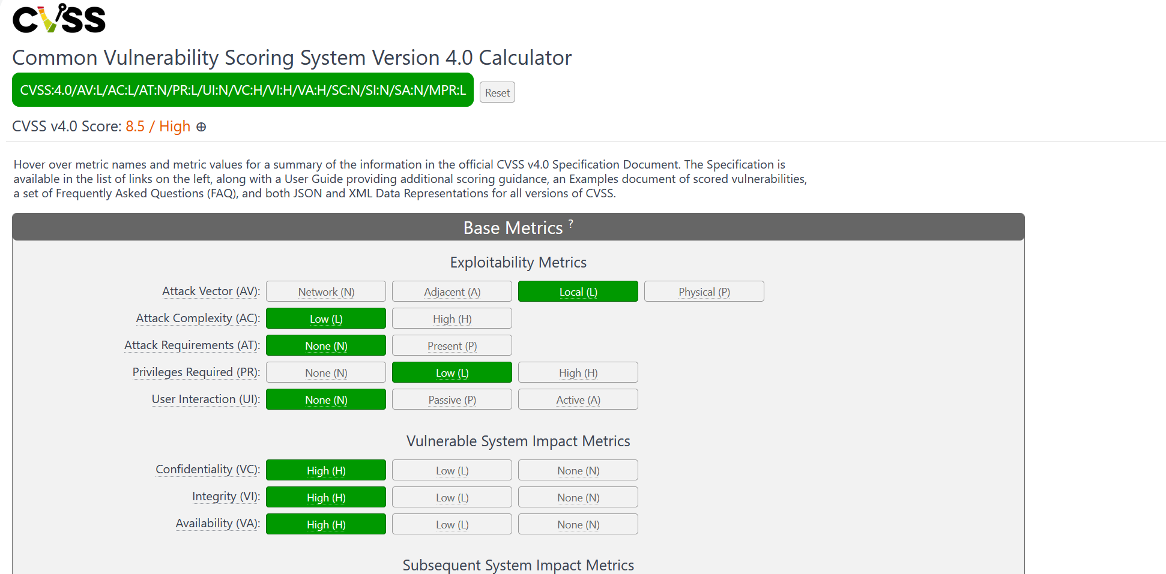

A vulnerability exists in a Type‑2 hypervisor installed on Windows hosts (e.g., a desktop virtualization platform used for running Linux VMs).
When the shared clipboard feature is enabled, a malicious program inside the guest VM can send a specially crafted clipboard message that triggers a memory‑handling flaw in the hypervisor’s Windows process.
The attacker must already control the guest VM, such as by convincing the user to import a malicious VM image or by compromising an existing VM. No special system conditions are required; the exploit works reliably when shared clipboard is enabled, which is the default configuration.
If exploited, the attacker can execute arbitrary code on the host Windows computer with the privileges of the user running the hypervisor. This allows modification of host files and installation of additional malware.
The attack does not require user interaction beyond running the malicious VM. The vulnerability does not allow direct compromise of other machines on the network.

- CVSS Scenario #2 (Can work together)
A popular brand of Bluetooth headphones supports wireless firmware updates through a companion mobile app.
The headphones do not properly validate the update packets sent over Bluetooth Low Energy (BLE). An attacker within Bluetooth range (approximately 10 meters) can send a spoofed firmware‑update packet that triggers a memory corruption vulnerability in the headphone firmware parser.
No pairing or authentication is required — the update channel is broadcast‑based and unauthenticated. The attack requires the victim’s headphones to be powered on but does not require any user action on the phone. The exploit works consistently and does not require special timing or conditions.
If exploited, the attacker can cause the headphones to crash and remain nonfunctional until reset. In the worst case, the attacker may overwrite configuration sections, preventing the headphones from pairing with the user’s phone. There is no access to phone data, microphone audio, or the mobile app. Only the headphones themselves are affected.

Attack Vector (AV)
The attacker must be within 10 meters/Bluetooth range, so I chose Adjacent

Attack Complexity (AC)
The scenario stated, “The exploit work consistently and does not require special timing or conditions”. It seemed straightforward and very reliable, so I chose Low

Attack Requirements (AT)
None because there were no mentions of a special system state being needed. Just powered on headphones.

Privileges Required (PR)
None because the scenario said, “no pairing or authentication is required.” Therefore, anyone nearby can send the packet without needing any credentials.

User Interaction (UI)
None because the headphones just need to be powered on. Does not take action.

Vulnerable System – Confidentiality
“There is no access to phone data, microphone audio, or the mobile app.” Nothing is read or leaked so I chose none.

Vulnerable System – Integrity
The attacker can overwrite headphone config settings, so I chose Low.

Vulnerable System – Availability
This can cause the headphones to crash or become broken. This can cause permanent damage so I chose High.

